***Roll No: Class: BE Division: A Date:***

-----------------------------------------------------------------------------------------------------------------

**TITLE:** Interfacing of 16x2 LCD with Arduino Board for display of message or information.

**AIM:** Understand the connection and configuration of 16x2 LCD and its use in programming.

**Task 1: Write a program to display name on first line and roll no. on second line of 16*2 LCD display.**

**Source Code:**

#include<LiquidCrystal.h>

LiquidCrystal lcd(6,7,2,3,4,5);

void setup(){

Serial.begin(9600);

lcd.begin(16,2);

lcd.setCursor(0,0);

lcd.print("Prathamesh");

lcd.setCursor(0,1);

lcd.print("Prathamesh");

Serial.println("34558");

Serial.println("Roll No.: 34558");

}

void loop(){

}

**Output:**

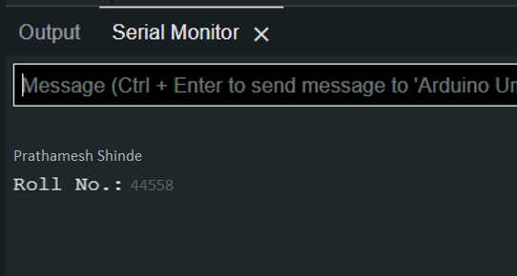

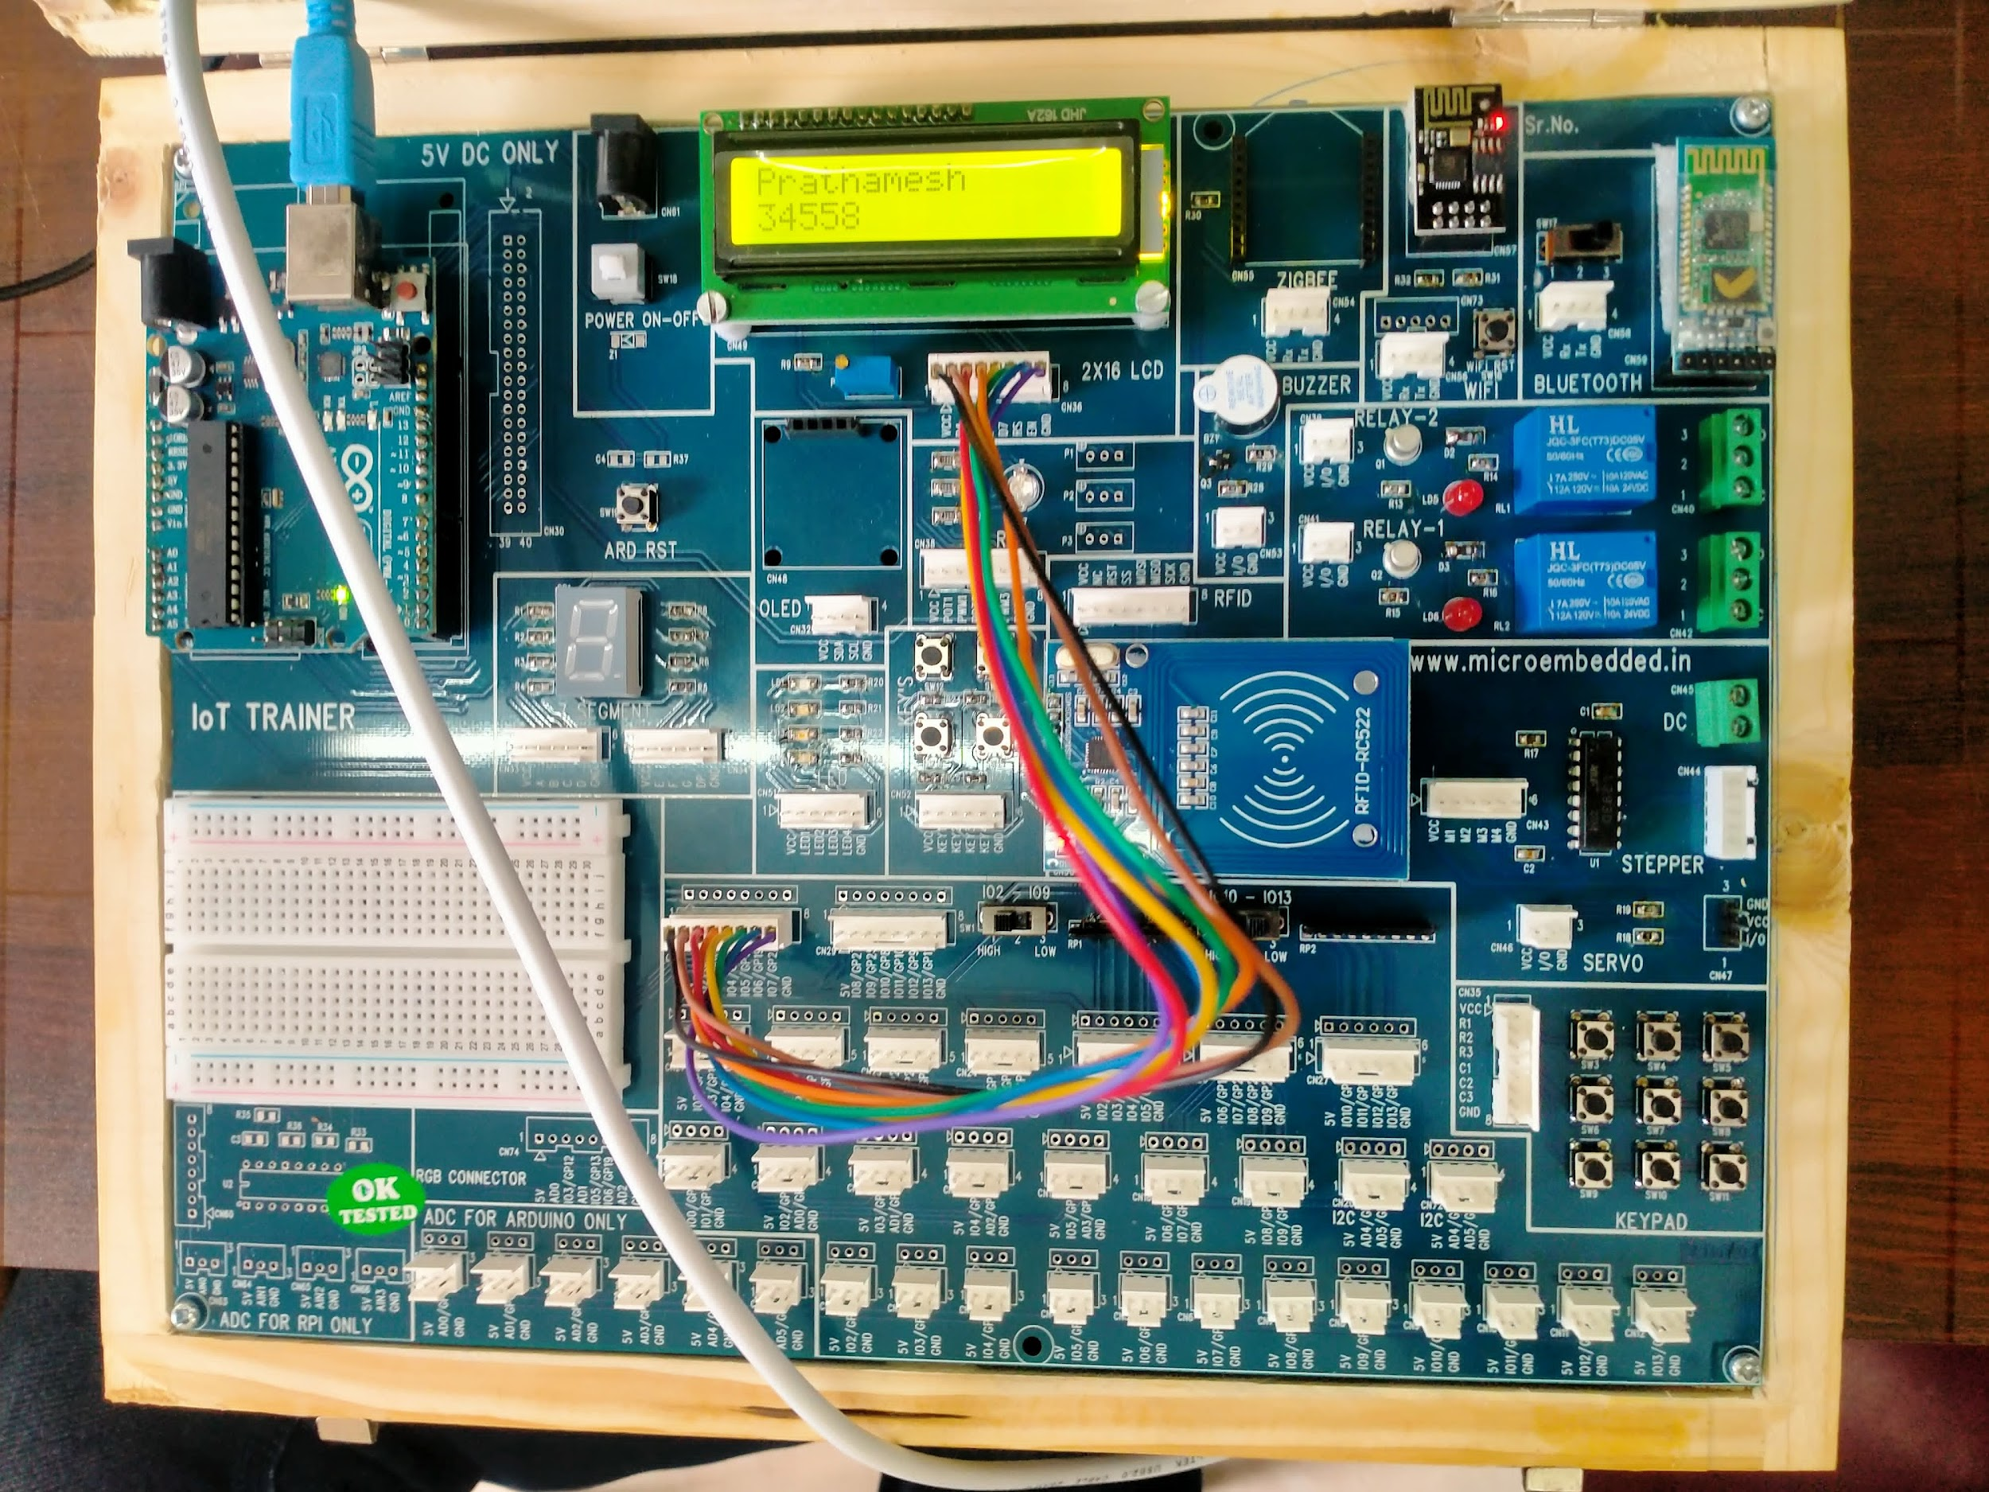

**Obervations:**